Fluorescent Materials for Non-Tracking Solar Energy Concentrators

# Peter Batley Magdalen College 18/1/2013

# Introduction

As fossil fuel supplies are steadily depleted and there is ever-increasing concern over the impact of climate change, renewable technologies are fast becoming an important source of energy. Photovoltaic (PV) cells represent one such renewable technology, converting sunlight into useful electrical energy. For large scale commercial power generation, arrays of solar panels have been built with mirror systems that track the sun, focussing its light onto the panels throughout the day. These systems are known as tracking solar concentrators. They are effective in regions where sunlight is consistent and there are large surface areas available for their construction. However, in regions that are often overcast or where lack of space is an issue they are not as suitable. Another increasingly common usage of PV cells is on the roofs of houses. A small fraction of the UK population has installed solar panels, mainly to take advantage of the high feed-in tariff offered by the government. The uptake has so far been modest, with many complaining about the aesthetics of the panels. Furthermore, the tariff has recently been decreased making solar panels less profitable to install.

An area for exploration is the use of fluorescent glass as a window material, with a small photovoltaic cell at the base of the window and mirrored edges for the remaining sides. Fluorescent glass absorbs photons of light and re-emits them in a random direction. Some of these randomly emitted photons will totally internally reflect within the glass window (and the mirrored edges) and eventually reach the PV cell at the base. If the properties of this glass were selected so as only to absorb light with wavelengths invisible to the human eye, energy would be collected without any detriment to the intended performance of the window. This system would be out of sight i.e. aesthetically no different to a modern window, and would not need a large space for installation, thus overcoming some of the disadvantages of the aforementioned systems. Additionally, only a small area of PV cell would be required, even for a relatively large window, allowing for a more efficient PV cell to be used despite the higher cost.

The following investigation constructs a simplified MATLAB model of the proposed non-tracking solar energy concentrator. Phase 1 is a brief assessment of the effectiveness of the concentrator, looking at the number of photons that are at wavelengths invisible to the eye and hence available for collection. Phase 2 introduces the consideration of reabsorption of photons within the concentrator. The effects of reabsorption are modelled more accurately in Phase 3. Finally, Phase 4 is an additional investigation into changing the visible light restriction within the model. Throughout, the aim is to maximise the fraction of photons reaching the PV cell i.e. the amount of energy captured.

# Phase 1 – Initial viability assessment

Before performing with any more detailed modelling it was necessary to quickly assess the viability of the system. Some initial assumptions were made for ease of calculation. Firstly, all light approaching the concentrator was assumed to be normal to its surface and reflections at the air-glass boundary were ignored. Secondly, it was assumed that the range of wavelengths that were absorbed by the glass did not significantly overlap the range of wavelengths that it emitted so the fraction of emitted photons that would reach the PV cell was given by the cosine of the critical angle. Thirdly, the absorption and emission spectra were assumed to be represented by Gaussian distributions of the form:

$$G\left(x\right)= exp⁡\left(\frac{{-\left(x-μ\right)}^{2}}{2σ^{2}}\right)$$

The system must still function as a normal window i.e. it must allow visible light through without significant absorption. Nominally, it was chosen that no more than 1% of ‘red’ photons (photons within the wavelength band that the human eye perceives as red) may be absorbed. This ‘red’ band encompassed higher wavelengths than the ‘green’ or ‘blue’ bands and hence would lie closest to the absorption spectrum. It was therefore necessary to calculate the minimum wavelength that corresponded to the 1% threshold.

The photon flux density spectrum (PFD) of incoming sunlight was found by dividing the given power density spectrum D(λ) by the photon energy: $P\left(λ\right)=\frac{λ.D\left(λ\right)}{h.c}$. The following plot shows the difference in shape between the two.

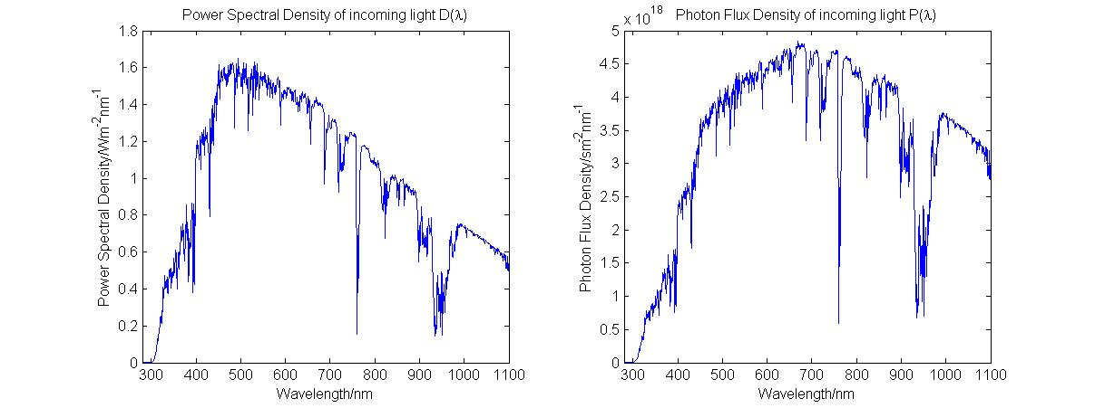

The short code segment below was then required to adjust the PFD spectrum (‘P_lambda’) so that it could be correctly multiplied with the ‘red’ sensitivity spectrum (‘Red_absorption’) giving the adjusted ‘red’ photon flux density spectrum (‘Red_absorption_photons’).

%Red absorption spectrum to red photons matrix adjustment

Adjustment_elements = [161:2:241,242:671];

Wavelength_in_nm_adjusted = Wavelength_in_nm(Adjustment_elements);

Red_absorption_photons = P_lambda(Adjustment_elements) .* Red_absorption;

Initially, the two spectra had data points at differing increments and over a different range of wavelengths so the ‘Adjustment_elements’ matrix was required to map one to the other. A slightly more detailed explanation can be seen in the comments of ‘Phase_1A_Initial_Viability_Test.m’.

Total_absorbed_red_photons = trapz(XYZ_Wavelengths,Red_absorption_photons);

loop_var_1 = 1;

for loop_var_1 = 1:length(XYZ_Wavelengths)

Red_photons_temp_1 = trapz(Red_absorption_photons(1:loop_var_1));

Percentage_red_absorbed = Red_photons_temp_1/Total_absorbed_red_photons;

if Percentage_red_absorbed < 0.99

loop_var_1 = loop_var_1 + 1;

else

break

end

end

The percentage of red photons absorbed was found by integrating the ‘red’ photon flux density up to a set wavelength and dividing by the integral over the whole wavelength range of the photon flux density. A ‘for’ loop (displayed above) incremented this wavelength until an ‘if’ condition caused the loop to terminate when the number of ‘red’ photons absorbed exceeded 99%. This gave a wavelength threshold of 672nm. The available number of photons above this wavelength was calculated to be 58.9% of the total number of incoming photons. This figure seemed adequately large to merit continuing the investigation.

The next stage was to consider the fluorescent material and assess its ability to collect the available invisible photons. The impact of the material on visible wavelengths, where t is the thickness of the PV cell (6mm throughout), is given by:

$$\int_{λ_{min}}^{λ_{max}}{CIE_X\left(λ\right)\left(1-exp⁡\left(-OD\left(λ\right).t\right)\right)dλ}$$

The optical density (OD) for absorption is given by a Gaussian distribution normalised by the maximum OD for absorption which was a given parameter. Given the frequency of its use throughout the project, a function to generate a Gaussian distribution for a given mean, standard deviation, and maximum and minimum ‘x’ values was written. To give adequate resolution, an incremental step size of 1/20th was chosen. This meant that some care was required when using the OD for absorption in the integral. Here, every 20th element was selected to give the OD only at wavelength values in increments of one (named ‘OD_absorption_conditioned’).

OD_absorption = Max_OD_absorption * Gaussian(Peak_absorption_wavelength,Standard_deviation,0,1100);

OD_absorption_conditioned = OD_absorption(1:20:((1100*20)+1));

Evaluating this integral using the given preliminary estimates for the absorption mean (790nm) and standard deviation (30nm) gave a percentage of visible light absorbed of 0.0054%, below the allowed 1% threshold set on ‘red’ light. Therefore, there was potential to increase the standard deviation of the absorption spectrum to allow for collection of more photons whilst still obeying this constraint. The fraction of photons reaching the PV cell was calculated at this stage to be 4.2%.

By simply repeating the code used for the prior calculation but using a variable standard deviation and incrementing it within a loop until the 1% ‘red’ threshold was reached, the optimal standard deviation was found to be 63.28nm. Initially, a coarser loop was run to save time giving a ballpark result of 63nm. The wavelength increment size was then decreased and the loop rerun starting with a standard deviation of 63nm to give the more accurate answer. With this new standard deviation, the fraction of photons reaching the PV cell had risen to 8.9%

# Phase 2 – Initial treatment of reabsorption

Having found the optimal standard deviation for absorption using a given initial peak absorption wavelength the next step was to include the effects of reabsorption. The only constraints considered so far were related to the impact upon visible light. However, the effects of reabsorption within the fluorescent material must also be considered. These arise from the fact that there will be some overlap between the emission and absorption spectra. As the standard deviation of the absorption spectrum is increased this overlap will increase accordingly. There should therefore be an optimum standard deviation whereby the number of photons reaching the PV cell is a maximum whilst the existing constraint on visible photons is still obeyed.

As a quick check for the significance of reabsorption before proceeding with the investigation, the OD of absorption at the peak emission wavelength (initially predicted as 940nm) was calculated and denoted by α. The corresponding fraction of light that would be absorbed at this wavelength could be found from: $(1-e^{-OD.t})$ where t is the thickness of the PV cell.

For a standard deviation of 63.28nm, α was found to be 6.02 and the percentage of light absorbed was 3.55%, i.e. the effects of reabsorption were significant.

The useful fraction of emitted photons reaching the PV cell, U, taking into account reabsorption, was now given by:

$$U=\frac{1}{πL}\int_{0}^{L}{\int_{0}^{π/2}{\int_{θ_{c}}^{π/2}{\left[exp\left(\frac{-αy}{\sin{θ}\sin{ϕ}}\right)+exp\left(\frac{-α\left(2L-y\right)}{\sin{θ}\sin{ϕ}}\right)\right]}}}\sin{θ}dy dϕ dθ$$

where L is the length/height of the window (fixed at 2m throughout)

The following code was part of a function (named ‘Phase_two_integral’) that performed this triple integration for a given value of α. The ‘@’ symbol declares a function handle with the listed variables. This allows the ‘triplequad’ function to be used and simply requires the integrand to be given along with the limits of the integral (given in pairs in the same order as the variables were declared in the function handle.)

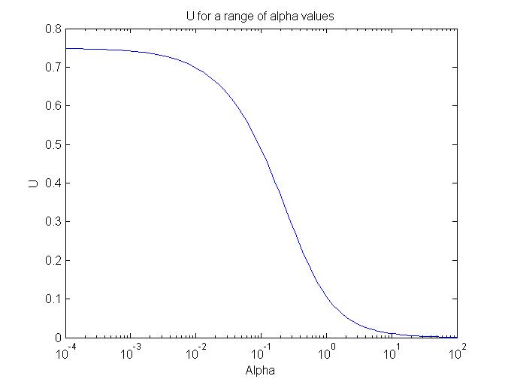

%Set up integrand function

P2_integrand = @(y, Phi, Theta)(exp(-(Alpha*y)/(sin(Theta)*sin(Phi))) + exp(-(Alpha*(2*L-y))/(sin(Theta)*sin(Phi)))) * sin(Theta);

%Triple integration

P2_integral = (1/(pi()*L))*triplequad(P2_integrand, y_min, y_max, Phi_min, Phi_max, Theta_min, Theta_max);

With this function created, a simple ‘for’ loop was set up to run through a logarithmic set of α values and the corresponding U value was calculated and plotted. It can be seen that as α tends to zero, i.e. the effects of reabsorption tend to zero, then U becomes the probability of a photon being retained in total internal reflection (74.9%). Conversely, as α tends to 100 the probability of a photon reaching the PV cell tends to zero i.e. all emitted photons are reabsorbed.

It now remained to calculate the total fraction of incoming photons that would reach the PV cell, taking into account this reabsorption estimation. This was given by:

$$Fraction of photons reaching PV cell = F x U$$

where F was the fraction of incident photons that would be absorbed by the fluorescent material, given by:

$$F=\frac{\int_{λ_{min}}^{λ_{max}}{P\left(λ\right)\left(1-e^{-OD\left(λ\right).t}⁡\right)dλ}}{\int_{λ_{min}}^{λ_{max}}{P\left(λ\right)dλ}}$$

Given its frequency of use a function to calculate F for a given standard deviation was created (named ‘Fraction_photons_absorbed_function’ in the code). The function simply evaluated the above ratio of integrals between wavelengths of 280nm and 1100nm (the boundaries of the initially given power spectral density of light.)

The following ‘for’ loop was run to find the optimal standard deviation. In this loop the standard deviation was incremented over a linear range of values between 30nm (the initially estimated standard deviation of absorption) and 63.2nm, the calculated limit on standard deviation due to the visible light constraint. Care was taken to select the correct α value from the OD absorption spectrum taking into account discretised nature of the coded Gaussian function. (Some lines of code have been wrapped due to their length. A semicolon denotes the end of a line as would be seen in MATLAB)

for sd_var_loop = linspace(30,63.2,100)

%Establish OD of absorption for current SD

OD_absorption = Max_OD_absorption *   
 Gaussian(Peak_absorption_wavelength,sd_var_loop,0,1100);

%Alpha is value of OD_absorption at 940nm i.e. element 940*20+1 of OD

Alpha = OD_absorption(940*20+1);

Fraction_reaching_PV_2 = Fraction_photons_absorbed_function(sd_var_loop) *   
 (Phase_two_integral(Alpha));

Fraction_reaching_PV_vec(loop_var_4) = Fraction_reaching_PV_2;

end

The following plot shows how the fraction of photons reaching the PV cell varies with standard deviation. Having run a finer loop to yield a more precise result, the optimum standard deviation was found to be 34.80nm. Beyond this value, the effects of reabsorption outweigh the benefits of initially capturing more photons by having a wider absorption spectrum, hence the fall in the number of photons reaching the PV cell.

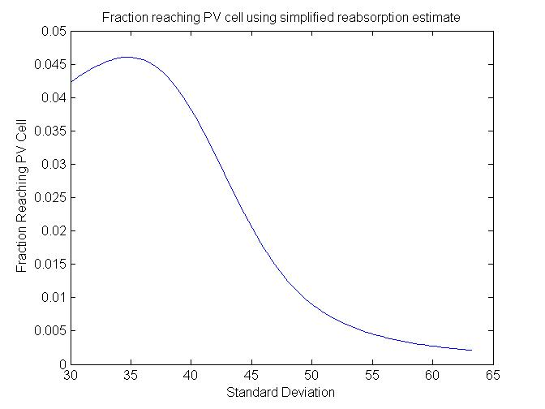

# Phase 3 – Refined treatment of reabsorption

The model in Phase 2 did not take into account the fact that a fluorescent material in fact emits photons over a range of wavelengths so reabsorption varies with wavelength i.e. the constant α is in fact a function of wavelength. To improve the model, emission was represented by the probability distribution G(λ), centred on the initially chosen wavelength of peak emission (940nm) and with a standard deviation equal to the standard deviation of the absorption maximum.

$$G\left(λ\right) = \frac{ exp⁡\left(\frac{{-\left(λ-μ\right)}^{2}}{2σ^{2}}\right)}{\int_{-∞}^{+∞}{exp⁡\left(\frac{{-\left(λ-μ\right)}^{2}}{2σ^{2}}\right)dλ}}$$

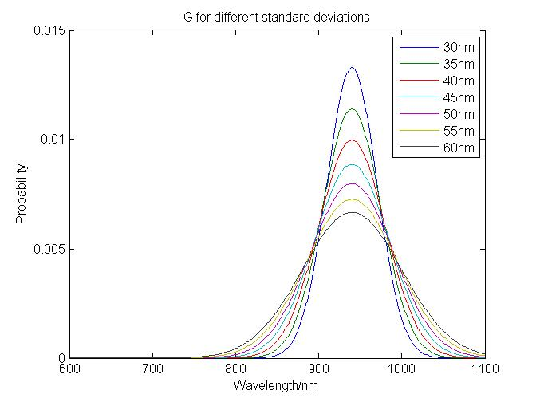As a check, G(λ) was plotted for several sample standard deviations. It can be seen below that as the width (standard deviation) of the distribution increases, the peak probability decreases, maintaining unit area below the graph as expected for a probability distribution.

With the revised reabsorption calculation, U became:

$$U=\frac{1}{πL}\int_{λ_{min}}^{λ_{max}}{G\left(λ\right)}\int_{0}^{L}{\int_{0}^{π/2}{\int_{θ_{c}}^{π/2}{\left[exp\left(\frac{-α\left(λ\right)y}{\sin{θ}\sin{ϕ}}\right)+exp\left(\frac{-α\left(λ\right)\left(2L-y\right)}{\sin{θ}\sin{ϕ}}\right)\right]}}}\sin{θ}dλ dy dϕ dθ$$

The triple integral part of U was exactly the same as in Phase 2 and so time could be saved by interpolating the results obtained earlier. This was done using the ‘interp1’ function. This function takes four inputs, the first two being the underlying function, the third being the vector of query points and the final being a string specifying the type of interpolation to be performed (e.g. nearest, linear, spline). It outputs a vector of values of the function at the given query points and can be seen used in the ‘for’ loop shown later. The following plot demonstrates the functionality of ‘interp1’ for a vector of query points with a much smaller increment than the underlying function. In this case the underlying function is the Phase 2 integral result as a function of α and the query points are a vector containing the values from 0 to 1100 in steps of 0.05.

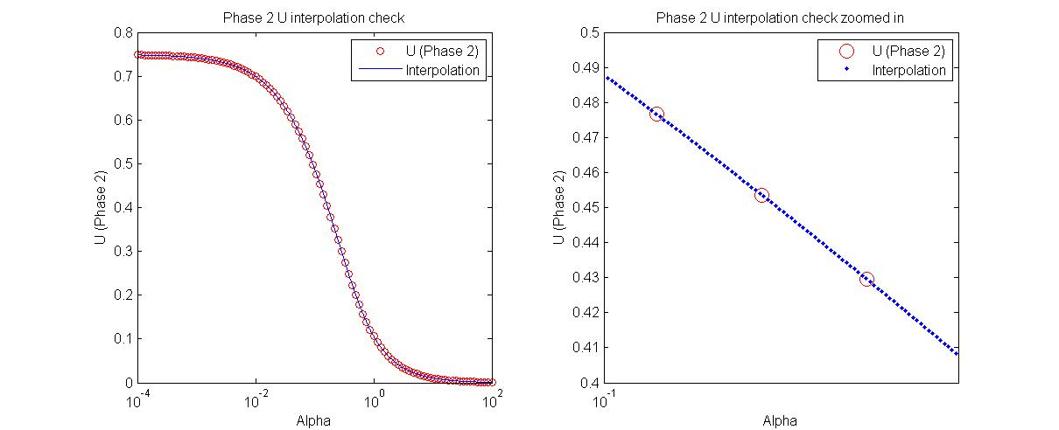

The following ‘for’ loop calculated the values of U for a range of standard deviations.

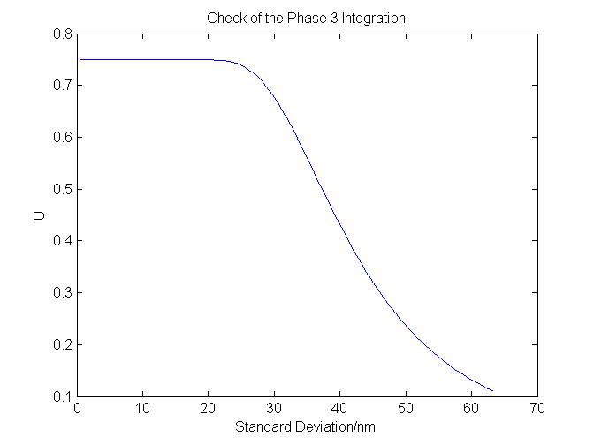

for SD_Phase_3 = SD_Phase_3_var

%Alpha is the OD of absorption

P3_Alpha = Max_OD_absorption * Gaussian(Peak_absorption_wavelength, SD_Phase_3, 0, 1100);

%Interpolate phase 2 integral results for all values of P3_Alpha

Phase_2_integral_result = interp1(P2_integral_lookup(:,1), P2_integral_lookup(:,2), P3_Alpha, 'spline');

%Establish G(lambda)

P3_Emission_OD = G_Lambda_function(SD_Phase_3,0:0.05:1100);

%Triple integral to find U

U_Phase_3_Integrand = P3_Emission_OD .* Phase_2_integral_result;

U_Phase_3 = trapz(0:0.05:1100,U_Phase_3_Integrand);

end

As expected, U decreases as the standard deviation increases due to the fact that the effects of reabsorption become increasingly dominant. Again, at low values of standard deviation when the overlap between the absorption and emission spectra is small, U tends towards the fraction of photons retained by total internal reflection.

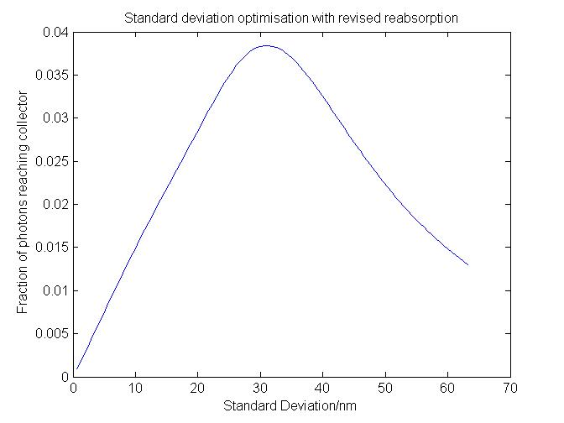

Finally, the total fraction of light reaching the PV cell was found by multiplying these U values by the corresponding vector of F values (as in phase 2). This gave an optimal standard deviation of 30.96nm and a total fraction of light reaching the PV cell of 3.84%, as can be seen on the adjacent plot.

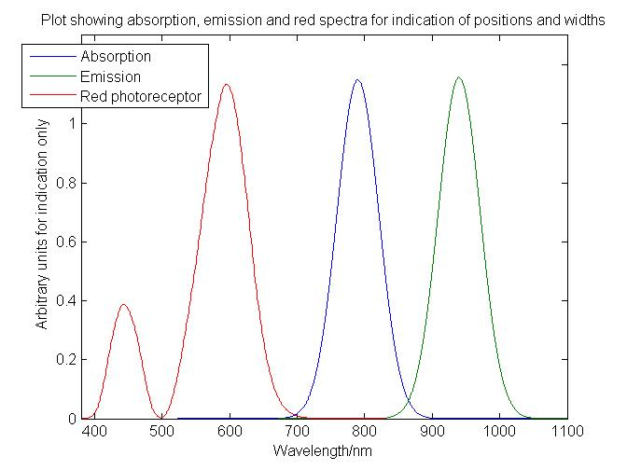The following plot summarises the initial stages of the project. It shows the three significant spectra with their relative widths and positions on the wavelength axis. The overlap between the absorption and emission spectra can be seen at around 870nm as well as the lesser overlap between the absorption and the ‘red’ photon spectra at around 690nm.

# Phase 4

Having produced a complete model for the system, including the effects of reabsorption, it was found that the optimum standard deviation of absorption was much smaller than the standard deviation that corresponded to the 1% ‘red’ light limit. This implied that there was further scope for optimisation by also varying the peak wavelength of absorption. The aim of this short, further investigation was to determine the optimal standard deviation and peak wavelength of absorption, and then to observe how the fraction of photons reaching the PV cell changed as the constraint upon visible light was changed.

The coding framework to do this was already largely in place from Phase 3. The final script in Phase 3 was converted into a function (‘Phase_4_Fraction_reaching_PV_Cell’) in terms of: standard deviation range to be optimised over, peak absorption wavelength, peak emission wavelength and some other necessary parameters. (Peak emission wavelength was included for completeness but was left constant throughout Phase 4 to reduce script execution time.) This function operated exactly as in Phase 3 and output the maximum fraction of photons reaching the PV cell as well as the optimal standard deviation (within the standard deviation range specified) for the given peak absorption wavelength.

To ascertain the upper bound on the standard deviation range to input into the above function, the calculation from Phase 1, (finding the maximum standard deviation allowable for a given percentage threshold on ‘red’ light) had to be performed. A function was created which output the fraction of visible light absorbed for given inputs of standard deviation and peak absorption wavelength (named ‘Phase_4_Fraction_visible_absorbed_function’).

for Peak_absorption_wavelength_loop = Wavelength_range

%Reset while loop variables on each loop

P4_SD_loop_1 = 10;

Visible_overlap = 0;

%For given peak absorption wavelength, find maximum sd that corresponds

%to visible light limit

while Visible_overlap < Visible_threshold;

Visible_overlap = Phase_4_Fraction_visible_absorbed_function(P4_SD_loop_1,Peak_absorption_wavelength_loop);

P4_SD_loop_1 = P4_SD_loop_1 + 0.01;

end

%Set this SD as the cap for the range of SD optimised over

SD_range = 10:0.05:(P4_SD_loop_1-0.01);

%Get maximum fraction absorbed (C) and optimal SD (D)

[C,D] =  
 Phase_4_Fraction_reaching_PV_Cell(SD_range,Peak_absorption_wavelength_loop,  
 940,Alpha_var,U_matrix);

%Create vectors of these for plotting

P4_Max_Fraction_vec(loop_var_10) = C;

Optimal_SD(loop_var_10) = D;

loop_var_10 = loop_var_10 + 1;

end

The above loop combines the two aforementioned functions to output the optimal standard deviation and fraction of photons reaching the PV cell for each peak absorption wavelength considered. The ‘while’ loop calculated the maximum allowable standard deviation for the given visible light threshold. This value was then used as the upper bound on the standard deviation input to the function optimising for fraction of visible light reaching the PV cell.

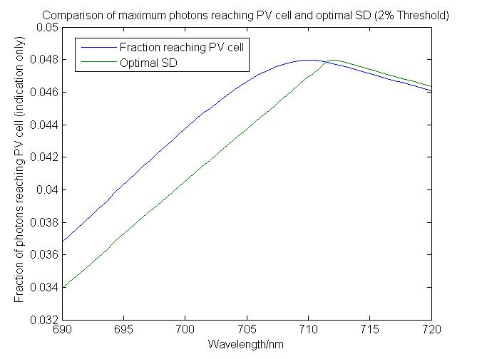Interestingly, it was found that the highest fraction of photons reaching the PV cell did not occur at the same peak absorption wavelength as the maximum standard deviation i.e. the overall optimum absorption spectrum was not the widest but was better positioned on the wavelength axis. Additionally, the sharp kink that can be seen in the ‘Optimal SD’ curve at around 712nm arises as the limiting factor on the standard deviation switches from the visible light constraint to the reabsorption constraint.

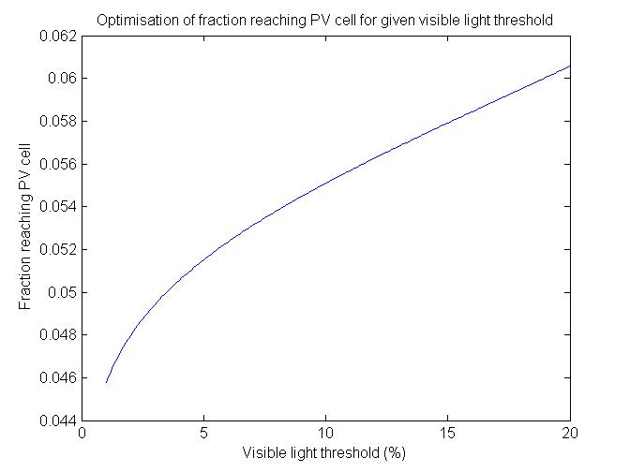The adjacent plot shows that, as expected, when the constraint upon visible light is relaxed, the fraction of photons reaching the PV cell is increased. In a room where the overall level of naturel light is not important, there is the potential to install a window that absorbs more of the visible light but collects a significantly increased percentage of sunlight.

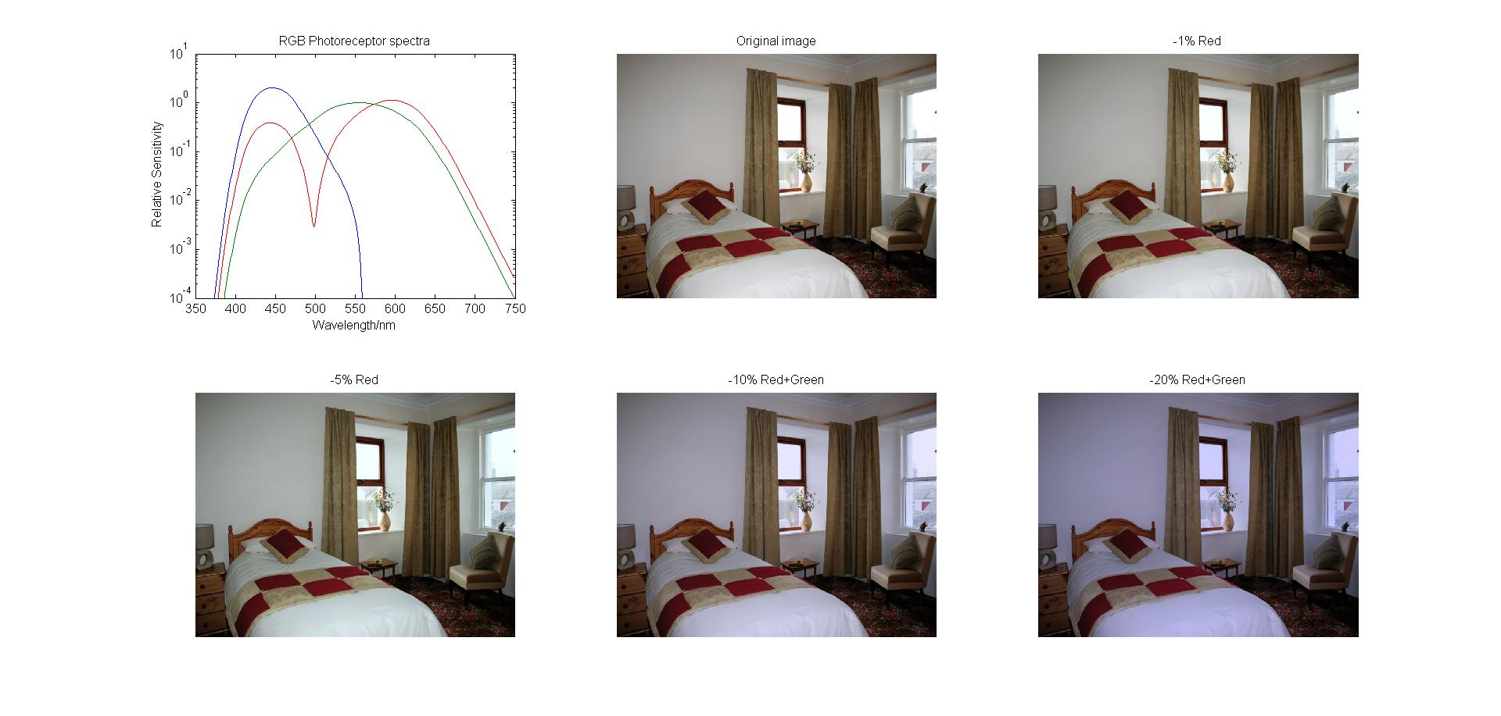This last image shows a ‘typical’ room with various filters applied to simulate the effects of fluorescent windows with different visible light thresholds. In the 10% and 20% cases, it was estimated that the overlap with the photoreceptor spectra would be large enough to affect both ‘red’ and ‘green’ photons. The pessimistic assumption was made that it would do so equally, despite the ‘green’ spectrum lying below the ‘red’ spectrum (as can be seen in the top left image of the photoreceptor spectra).

# Conclusion

In conclusion, the non-tracking concentrator considered does have the potential to collect a significant fraction of sunlight if a fluorescent material with the correct properties can be found. There is also further scope for optimising the parameters of the material by allowing the peak wavelength of emission to vary.

In London, the average power from the sun is around 120W/m2. For a window with a visible threshold set at around 4%, the fraction of photons reaching the PV cell would be roughly 0.05. This equates to around 6W/m2 being collected before PV cell efficiency is taken into consideration. At the moment, the very best PV cells in development have reached 44% efficiency but are likely not yet commercially viable [1]. Given the small size of the PV cell required it is assumed that a cell with an efficiency of 25% can be found leading to a power of 1.5W/m2 being collected. For comparison, a standard rooftop solar panel is around 10% efficient and would collect about 12W/m2. [2]

Although the power collected with a non-tracking fluorescent concentrator is small, there is potential for very simple and widespread installation. In large enough numbers i.e. installation on every new window in the UK and on large skyscrapers, the overall power contribution would be significant and would help towards meeting green energy goals that are required if the effects of global warming are to be halted.

[1] http://en.wikipedia.org/wiki/File:PVeff(rev121211).jpg  
[2] http://www.edfenergy.com/energyfuture/energy-gap-quantity/solar-and-the-energy-gap-quantity